3 different branches Jenkins jobs of docker container

- Create one ec2 instances
- Install git ,java and docker
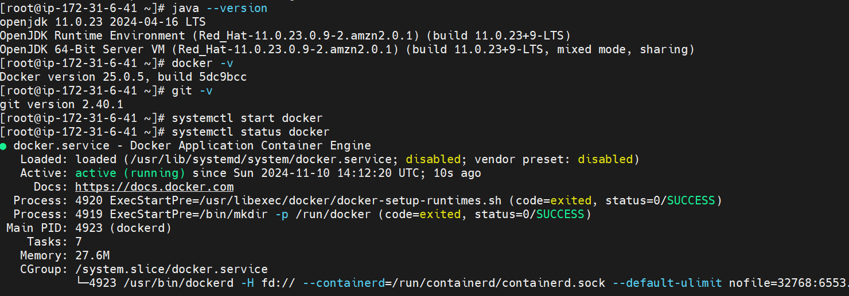

- Create 3 branches and push index.html file contains
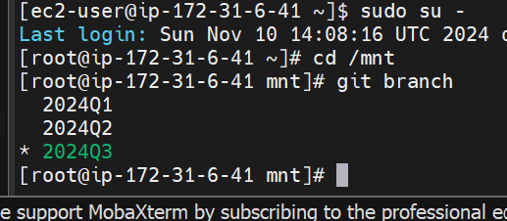

- Create one repository on git hub and push all branches on git hub
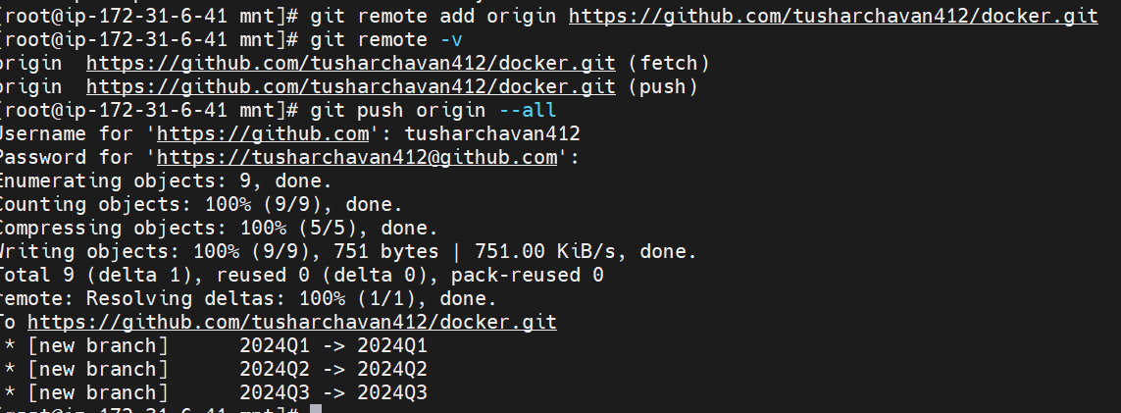

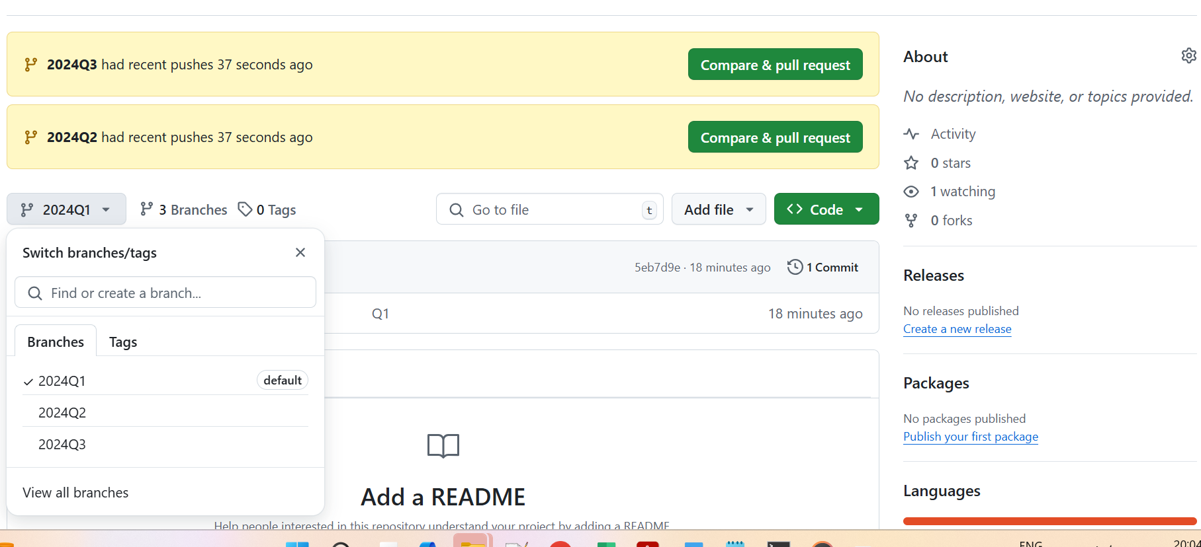

- Now create 3 containers so that pull httpd images
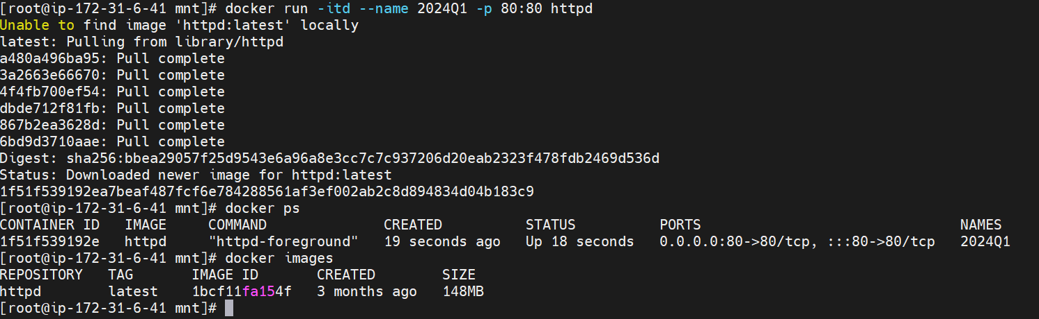

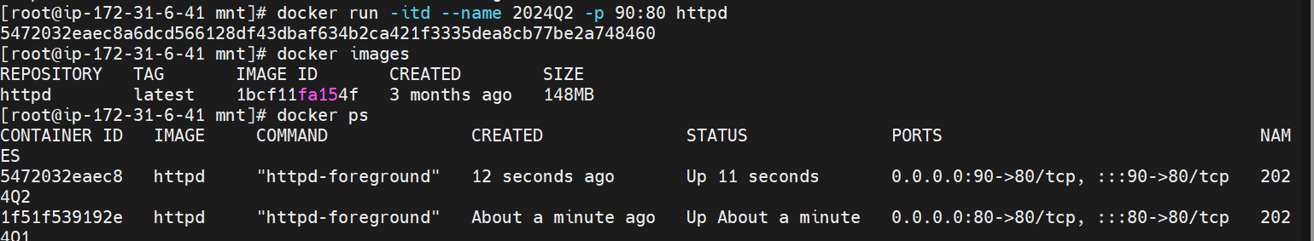

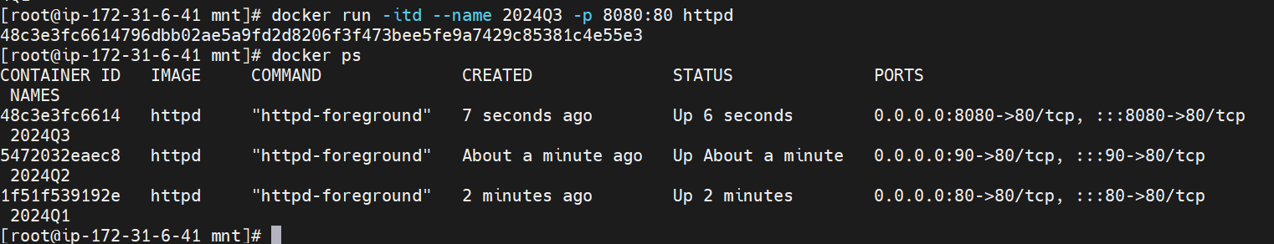

- Install Jenkins as war application
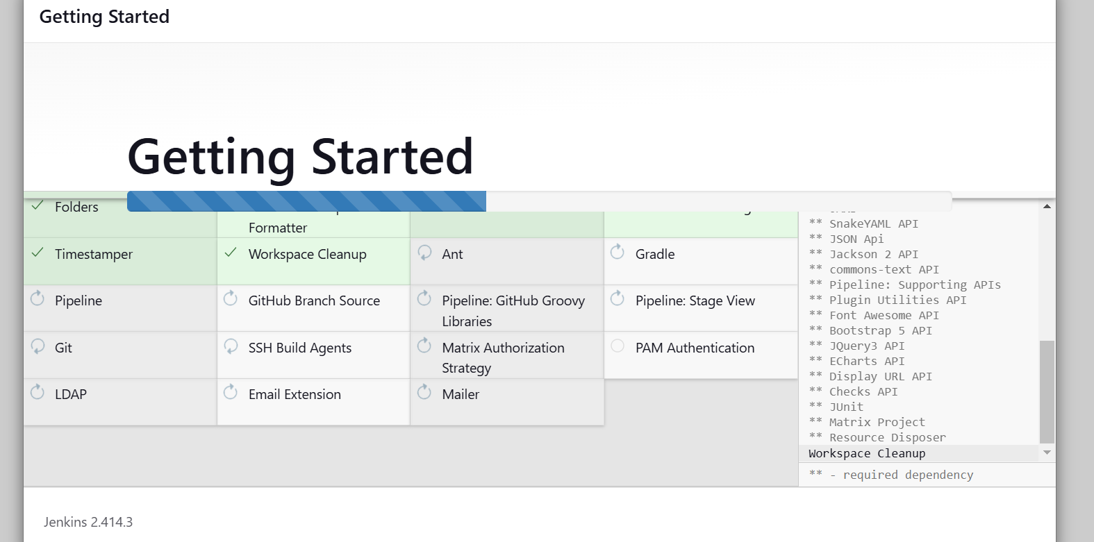

- Create pipline

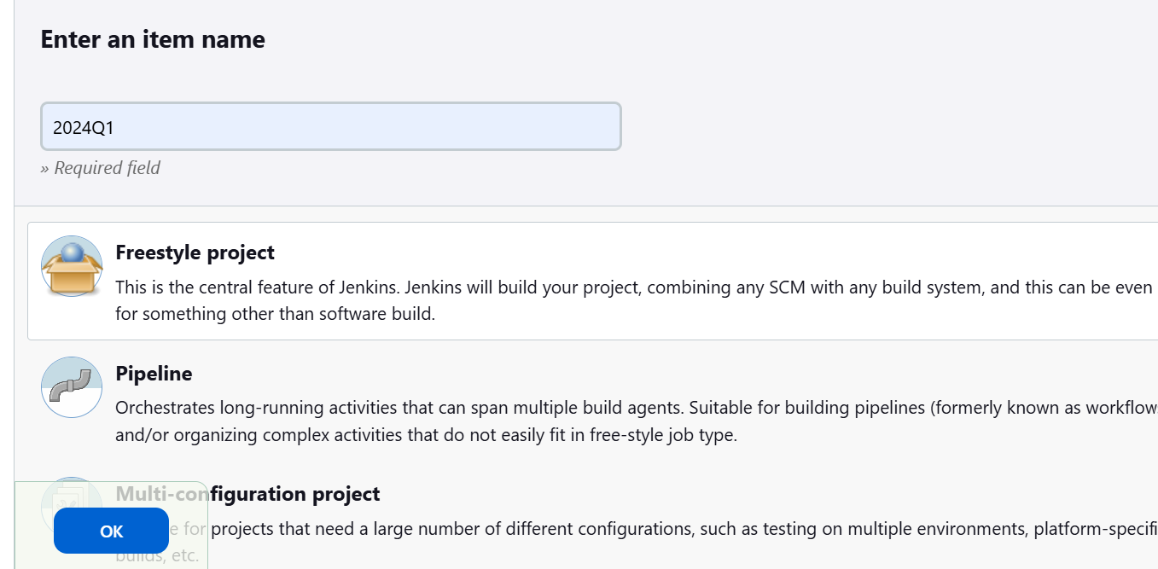

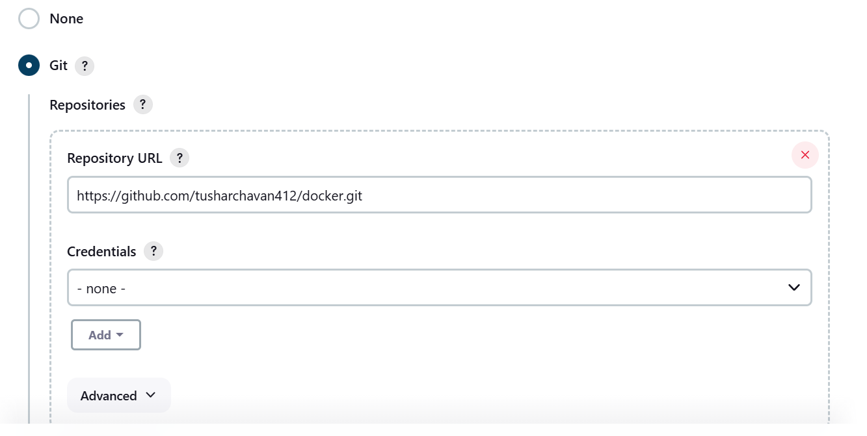
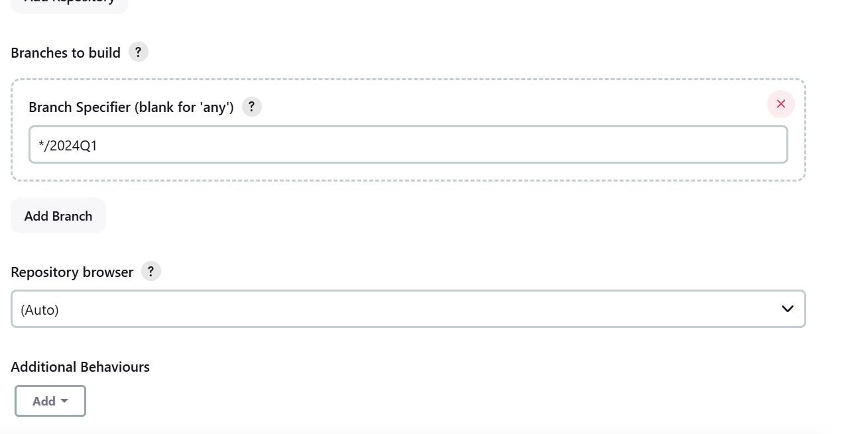

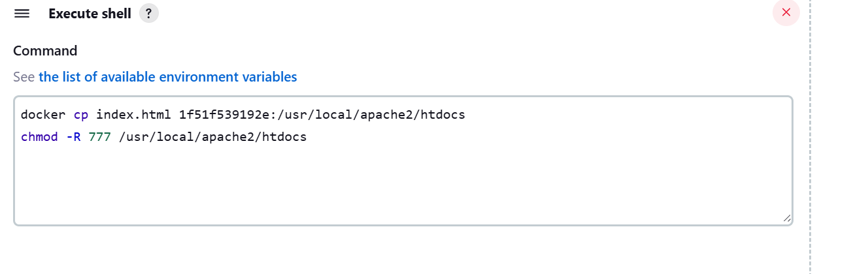

Started by user Tushar Chavan
Running as SYSTEM
Building in workspace /root/.jenkins/workspace/2024Q1
The recommended git tool is: NONE
No credentials specified
> git rev-parse --resolve-git-dir /root/.jenkins/workspace/2024Q1/.git # timeout=10
Fetching changes from the remote Git repository
> git config remote.origin.url https://github.com/tusharchavan412/docker.git # timeout=10
Fetching upstream changes from https://github.com/tusharchavan412/docker.git
> git --version # timeout=10
> git --version # 'git version 2.40.1'
> git fetch --tags --force --progress -- https://github.com/tusharchavan412/docker.git +refs/heads/*:refs/remotes/origin/* # timeout=10
> git rev-parse refs/remotes/origin/2024Q1^{commit} # timeout=10
Checking out Revision 5eb7d9efa621a2aa73ed2a7a7781d35bfc517d17 (refs/remotes/origin/2024Q1)
> git config core.sparsecheckout # timeout=10
> git checkout -f 5eb7d9efa621a2aa73ed2a7a7781d35bfc517d17 # timeout=10
Commit message: "Q1"
> git rev-list --no-walk 5eb7d9efa621a2aa73ed2a7a7781d35bfc517d17 # timeout=10
[2024Q1] $ /bin/sh -xe /mnt/apache-tomcat-9.0.97/temp/jenkins1096909218582193262.sh
+ docker cp index.html 1f51f539192e:/usr/local/apache2/htdocs
Finished: SUCCESS

- Then hit public IP address with port number (http://3.110.176.201:80)



- Same create other jobs
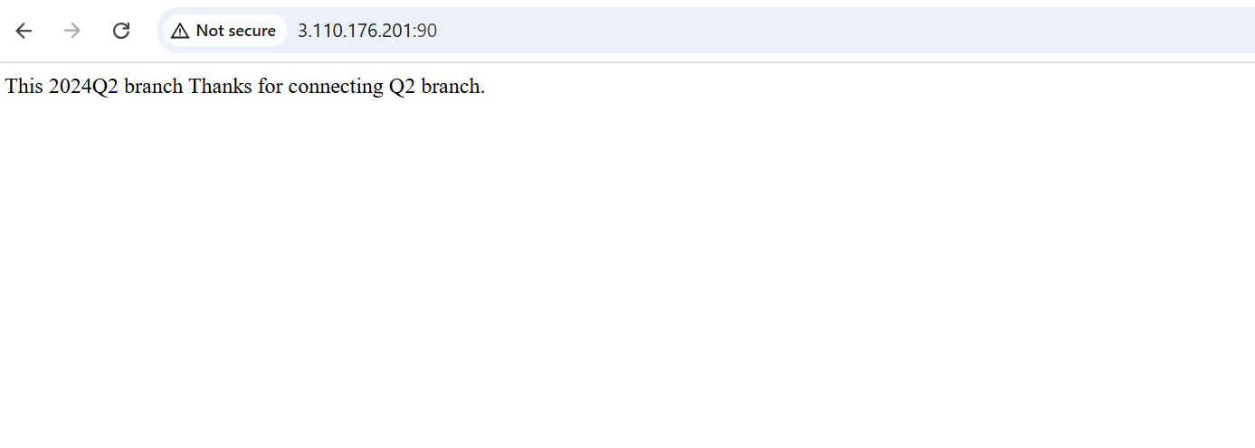



Through declarative pipeline

pipeline{
agent{
label{
label "built-in"
}
}
stages{
stage("Git Clone"){
steps{
sh '''

cd /mnt
rm -rf docker
git clone 'https://github.com/tusharchavan412/docker.git' -b 2024Q1
docker cp /mnt/docker/index.html e23d98762938:/usr/local/apache2/htdocs

'''
}
}
}
}

Create three Job for different branches
Output:-

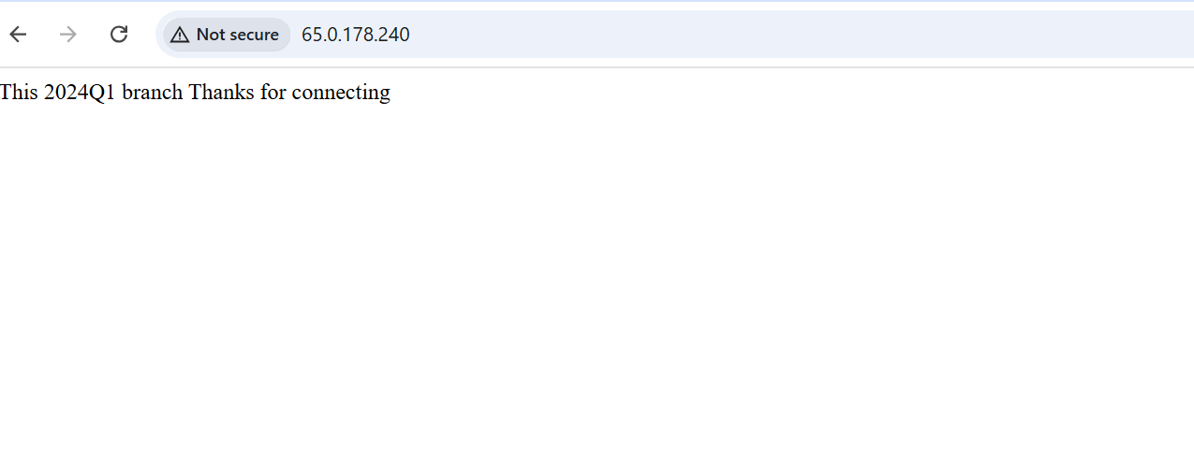

pipeline{
agent{
label{
label "built-in"
}
}
stages{
stage("Git Clone"){
steps{
sh '''

cd /mnt
rm -rf docker
git clone 'https://github.com/tusharchavan412/docker.git' -b 2024Q2
docker cp /mnt/docker/index.html fbe40454c4f7:/usr/local/apache2/htdocs

'''
}
}
}
}

Build the jobs
Hit Ip address :- http:// 65.0.178.240:90/

Output



3rd Job

pipeline{
agent{
label{
label "built-in"
}
}
stages{
stage("Git Clone"){
steps{
sh '''

cd /mnt
rm -rf docker
git clone 'https://github.com/tusharchavan412/docker.git' -b 2024Q3
docker cp /mnt/docker/index.html fb6eb4c18babed:/usr/local/apache2/htdocs

'''
}
}
}
}

Build the job

Hit :- http:// 65.0.178.240:91/



